Q 1. Describe the role of Agile principles in enhancing collaboration and productivity in software teams.
Ans: The Agile Alliance defines a set of 12 agility principles that guide teams in achieving agility, emphasizing that an agile team is a nimble team able to appropriately respond to changes. These principles foster an environment where communication is facile, planning is flexible, and the "us and them" attitude between business and technical teams is eliminated.
- Customer Satisfaction: The highest priority of the agile team is to satisfy the customer through the early and continuous delivery of valuable software, which drives productivity by focusing on value.
- Embracing Change: Agile processes welcome changing requirements, even late in development, harnessing change for the customer's competitive advantage rather than resisting it.
- Daily Collaboration: Business people and developers must work together daily throughout the project to ensure that technical work aligns constantly with business needs.
- Face-to-Face Communication: The most efficient and effective method of conveying information to and within a development team is face-to-face conversation, which reduces misunderstandings.
- Motivated Individuals: Projects should be built around motivated individuals who are given the environment, support, and trust they need to get the job done effectively.
- Sustainable Development: Agile processes promote sustainable development, allowing sponsors, developers, and users to maintain a constant, productive pace indefinitely without burnout.
- Self-Organizing Teams: The best architectures, requirements, and designs emerge from self-organizing teams, as the team itself is best positioned to determine how to accomplish the work.
Conclusion: These principles define an agile spirit that prioritizes individuals and interactions, resulting in teams that can adapt tasks, streamline processes, and deliver working software incrementally.
Q 2. Explain the following : (1) Adaptive software Development (2) Crystal
Ans: Adaptive Software Development (ASD) and Crystal are agile frameworks that prioritize human collaboration, team self-organization, and adaptability over rigid process adherence to manage complex systems effectively.
- ASD - Speculation Phase: This initial phase focuses on adaptive cycle planning, using the customer's mission statement, constraints, and basic requirements to define the necessary release cycles.
- ASD - Collaboration Focus: ASD relies on motivated people working together in a way that multiplies their talent, requiring mutual trust to criticize without animosity and assist without resentment.
- ASD - Continuous Learning: Teams engage in learning through focus groups, technical reviews, and project postmortems to improve their understanding of the technology and process as work proceeds.
- ASD - Self-Organizing Teams: Highsmith argues that self-organization among collaborative teams is as much a source of order in complex interactions as traditional engineering discipline.
- Crystal - Cooperative Game: Crystal views software development as a "resource-limited, cooperative game of invention and communication" with a primary goal of delivering useful, working software.
- Crystal - Family of Methodologies: Crystal is not a single method but a family of agile processes (e.g., Clear, Orange), allowing teams to select the variant that best fits their project's size and criticality.
- Crystal - Genetic Code: While each Crystal method has unique roles and patterns, they all share the same "genetic code" or core principles that prioritize maneuverability and communication.
Conclusion: Both methodologies emphasize that the process must be molded to the specific needs of the people and the project environment rather than enforcing a rigid structure.
Q 3. Identify the importance of Dynamic Systems Development Method.
Ans: The Dynamic Systems Development Method (DSDM) is an agile process model, governed by the DSDM Consortium, which is designed to ensure the delivery of high-quality systems by focusing on tight control of the development process and continuous business involvement.
- Delivery on Time and Budget: It is important because its framework is structured to deliver systems on time and on budget through disciplined, incremental delivery of software.
- Agile Process Control: DSDM defines a clear agile process model, including a life cycle with distinct activities, ensuring that the project adheres to a proven, adaptable framework.
- Accommodation of Requirements: It is designed to handle evolving requirements by incrementally delivering software where changes have been requested and accommodated as more is learned.
- Feasibility Check: The initial Feasibility Study is critical as it assesses whether the application is a viable candidate for DSDM, based on the established business requirements and constraints.
- Focus on Business Value: The Business Study ensures the application will provide business value by establishing the necessary functional and information requirements at the outset.
- Evolutionary Prototyping: The Functional Model Iteration is important because it produces incremental prototypes that are intended to evolve into the deliverable application, making the prototypes directly valuable.
- Operational Engineering: The Design and Build Iteration ensures that prototypes are properly engineered to provide operational business value for end users, guaranteeing both function and technical quality.
Conclusion: DSDM is a crucial agile method that integrates rigorous process structure with incremental delivery to ensure reliable outcomes that meet business needs.
Q 4. Explain how XP practices support ongoing communication with the customer.
Ans: Extreme Programming (XP) places communication as one of its five core values, establishing a foundation that drives specific practices designed to ensure continuous, high-bandwidth interaction and feedback between the development team and the customer.
- Communication Value: Communication is a fundamental value in XP, driving all specific activities, actions, and tasks to ensure effective transfer of information between software engineers and other stakeholders.
- Informal Collaboration: XP emphasizes close, yet informal (verbal) collaboration between customers and developers, and actively avoids voluminous documentation as the primary communication medium.
- Planning Game - Listening: The planning activity begins with listening , which is a requirements gathering activity that enables the technical members of the XP team to fully understand the business context for the software to be built.
- Customer-Written User Stories: Communication is formalized through user stories, which are required output, features, and functionality for the software, and are explicitly written by the customer and placed on an index card.
- Value and Cost Assignment: The customer assigns a value (priority) to each story based on its business worth, while the XP team assesses the cost in development weeks, which requires a collaborative discussion on feasibility and priority.
- Rapid Feedback on Cost: As new requirements (stories) are derived during iterative planning, the team must provide the customer with rapid feedback regarding the cost and schedule impact of implementing these changes.
- Acceptance Testing (Customer Tests): The customer is responsible for specifying acceptance tests (also called customer tests) derived from the user stories, which serve as a critical form of continuous feedback on the system's functionality.
Conclusion: Through its dedication to communication, XP systematically embeds the customer into the process via stories, feedback, and testing to ensure constant alignment between development and business needs.
*Q 5. Explain Safe Home Security functions for Flow Oriented Modelling and Behavioural Modelling.
Ans: The Safe Home Security system is an excellent case study for applying software engineering models. Flow-oriented modeling (e.g., Data Flow Diagram - DFD) illustrates how data moves through the system, while behavioral modeling (e.g., State Diagram) captures how the system's mode of operation changes in response to external events.
- Flow-Oriented Model Purpose: The flow-oriented model for Safe Home depicts the transformation of data input from sensors (e.g., door contact, motion) into information required to make decisions or activate alarms.
- Key Input/Output: The model identifies the homeowner as the source/sink for commands (Arm/Disarm) and the sensors as the primary sources of data, with alarms/actuators as the system's final output sinks.
- Core Process: Sensor Monitoring: A central flow process involves the continuous monitoring of sensor inputs, where the raw data is checked, filtered, and passed to subsequent processes for decision-making.
- Process: Alarm Determination: A significant process is Alarm Determination, which receives sensor status and the system's current armed state, using this information to calculate the need for an alarm and trigger an output flow.
- Behavioral Model Purpose: The behavioral model defines the system's discrete operational states, such as Armed (Away), Armed (Stay), and Disarmed, which dictate how the system processes sensor data.
- State Transitions: The model captures events (e.g., correct password entry, sensor trigger) that cause the system to transition from one stable state to another, defining the allowed paths of operation.
- Alarm State Definition: A specific and critical state is the Alarm State, detailing the sequence of actions the system executes when an intrusion is detected (e.g., sounding the siren, sending a notification, or initiating a call).
Conclusion: Flow modeling shows the necessary data transformations, while behavioral modeling ensures the system reacts correctly to events by shifting between defined operational modes.
Q 6. Explain design modelling principles that guide the respective framework activity.
Ans: Design modeling is the framework activity that defines the technical plan for software construction. The following principles guide this activity, ensuring the design is coherent, traceable, and focused on delivering a high-quality, maintainable system.
- Principle 1. Design should be traceable to the requirements model: Every element in the design must be directly linked to an existing requirement in the requirements model, ensuring all customer needs are addressed.
- Principle 2. Always consider the architecture of the system to be built: Design must focus on the overall architecture first, as it defines the structural integrity and high-level organization of the system.
- Principle 3. Data is just as important as the processing functions: The design should devote as much attention to the structure and characteristics of the data as it does to the algorithms that manipulate the data.
- Principle 4. Interfaces (internal and external) must be designed with care: All interfaces—user, internal component-to-component, and external system-to-system—must be well-defined and robust to ensure flawless communication and integration.
- Principle 5. User interface design should be tuned to the needs of the end user: User interface design must be informed by the needs of the end user, and in every case, it should stress ease of use. A poor interface, regardless of sophisticated internal functions, often leads to the perception that the software is "bad."
- Principle 6. Component-level design should be functionally independent: Functional independence is a measure of the "single-mindedness" of a software component. The component's delivered functionality should be cohesive—focusing on one and only one function or subfunction.
- Principle 7. Components should be loosely coupled to one another and to the external environment: As the level of coupling between components increases, the likelihood of error propagation also increases and the overall maintainability decreases. Therefore, coupling should be kept as low as is reasonable.
Conclusion: These principles ensure that the design modeling activity produces a disciplined, quality-focused blueprint that is easy to understand, maintain, and directly relates to the original customer requirements.
Q 7. State the benefits and challenges of using Feature Driven Development in software development.
Ans: Feature Driven Development (FDD) is an agile process model centered on delivering small, client-valued functions called "features," making it suitable for larger, object-oriented projects.
Benefits of Feature Driven Development (FDD)
- Clearer User Feedback: Features are small blocks of deliverable functionality, making them easier for users to describe, understand, and review for errors or ambiguity.
- Organized Project Tracking: Features are grouped hierarchically, which allows project planning, scheduling, and tracking to be driven naturally by the feature structure.
- Continuous Value Delivery: The definition of a feature as the deliverable increment means the team develops operational features every two weeks, ensuring rapid and continuous progress.
- Improved Software Quality: Features are small, making their design and code representations easier to inspect effectively. FDD also formalizes QA through design/code inspections and audits.
- Robust Project Management: FDD emphasizes formal project management guidelines and defined milestones to manage the complexity and project status of moderately sized and larger software projects.
Challenges (Implied by FDD Structure)
- Strict Feature Size Discipline: Success relies on features being truly implementable in two weeks or less. If features are poorly defined or too large, the process breaks down.
- Management Overhead: FDD defines six mandatory milestones (design walkthrough, design, design inspection, code, code inspection, promote to build) for each feature, which adds process overhead compared to simpler agile methods.
- Modeling Dependency: The first two processes, Develop an Overall Model and Build a Features List, are foundational. Failure to accurately complete this upfront modeling risks disrupting the subsequent feature-driven cycles.
Conclusion: FDD provides a scalable, disciplined agile process that enhances collaboration and quality by focusing on small, user-valued increments with clear management visibility.
Q 8. Discuss the benefits and challenges of using Scrum in software development
Ans: Scrum is an agile software development method that uses principles consistent with the agile manifesto to guide work through fixed-length, iterative cycles called "sprints," helping teams manage complex projects.
- Handling Uncertainty: Scrum's process patterns enable a software team to work successfully in a world where the elimination of uncertainty is impossible, as the framework assumes the existence of chaos upfront.
- Priority Management: Requirements are managed via the Product Backlog—a prioritized list of requirements. The product manager can add items (changes) at any time and update priorities as required.
- Team Communication: The Scrum meetings (typically 15 minutes, held daily) help the team to uncover potential problems as early as possible and lead to "knowledge socialization," thereby promoting a self-organizing team structure.
- Stable Work Environment: The work conducted within a sprint (a predefined time-box) is stable because changes are not introduced during the sprint, allowing team members to focus on completion.
- Frequent Customer Feedback: The Demos process delivers the software increment to the customer so that implemented functionality can be demonstrated and evaluated by the customer periodically.
- Challenge: Strict Time-box Adherence: The requirement that work units must fit into a predefined time-box and that no changes are introduced during the sprint demands strict discipline and stakeholder patience.
- Challenge: Discipline of Daily Meetings: The process relies on the team consistently holding short (15-minute) daily meetings and the Scrum master assessing the responses to keep the team aligned and uncover obstacles.
Conclusion: Scrum's strength lies in its ability to manage chaos through prioritized work, time-boxed stability, and continuous feedback, but its success is dependent on high adherence to its defined meeting and sprint structure.
Q 9. Illustrate the different ways of categorizing software projects
Ans: Software projects are categorized based on several characteristics to tailor project management and planning to the specific context of the work.
- Changes to the Characteristics of Software Projects: The original text does not have a distinct heading for this, but the context for categorization implies that the characteristics of software projects can change over time. For instance, a small, internal project might evolve into a large, externally sold software product, altering its management and quality requirements.
- Compulsory versus Voluntary Users: A key categorization is based on user engagement. The text notes that in workplaces, some systems are compulsory—staff must use them (e.g., for recording a sale). In contrast, the use of other systems, such as computer games, is voluntary, which makes requirements harder to elicit for the voluntary group.
- Information Systems versus Embedded Systems:
  - Information Systems are the traditional systems that enable staff to carry out office processes, such as a stock control or industrial control system.
  - Embedded Systems (also known as process control systems) are those that are designed to control machines, for example, a system that controls air conditioning equipment in a building.
- Software Products versus Services:
  - Software Product Projects involve developing software for general customers. The resulting software is typically sold off-the-shelf to a large number of buyers (e.g., operating systems).
  - Software Services Projects cover a large range of activities, including outsourcing, maintenance, testing, and consultancy. These projects often involve customizing existing software to meet specific customer requirements.
- Outsourced Projects: While not a separate category in the text, outsourcing is mentioned as a major activity within Software Services Projects. Outsourced projects involve one organization contracting out the development or maintenance of software to an external third-party provider.
- Objective-Driven Development: Projects can be distinguished by whether the aim is to produce a product (specified by the client) or to meet certain objectives. In objective-driven development, the focus is on achieving a desired business outcome, and the client holds the responsibility for justifying the product itself.
Conclusion: Software project classification provides a necessary initial lens for project managers, allowing them to select appropriate processes based on user type, technical domain, and commercial goal.
Q 10. Illustrate the project management life cycle with a neat diagram
Ans: The project management life cycle defines the necessary, structured framework for controlling a software project's evolution, ensuring its objectives are met through four main sequential stages.
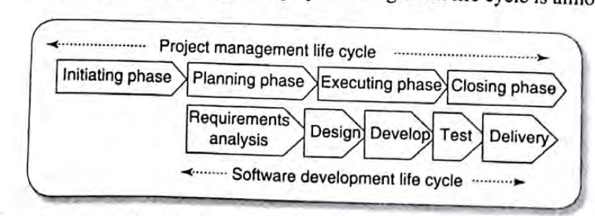
- Project Initiation: This initial stage is concerned with defining the scope and viability. It involves a mandatory feasibility study (technical and financial viability) and often utilizes the W5H principle (What, When, Why, Who, Where, How) to gain clarity. During the "project bidding" process, formal documents are often exchanged:
  - Request for Quotation (RFQ): Used when the requirements are well-defined and the main variable is the price.
  - Request for Proposal (RFP): A formal invitation for suppliers to propose a solution and estimate costs for a project with complex or less defined requirements.
  - Request for Information (RFI): A preliminary document to gather general supplier capabilities and market knowledge.
- Project Planning: The core of this stage is building the project's roadmap and establishing measurable objectives. The planning output includes key subsidiary plans:
  - Project Plan: Defines the overall schedule, tasks, and milestones.
  - Resource Plan: Determines necessary human resources, skills, and equipment.
  - Financial Plan: Establishes the budget, cash flow, and financial controls.
  - Quality Plan: Sets the quality standards and assurance activities for the software delivery.
  - Risk Management Plan: Identifies, analyzes, and plans responses to potential threats.
- Project Execution: This is the stage where the main development work takes place, implementing the plans created. Activities include the design, coding, and testing of the software. The focus is on building the system according to specification while actively monitoring progress and resolving any issues.
- Project Closure: The project is formally ended in this stage. Key activities include the installation and sign-off of the software by the client, performing final acceptance tests, and conducting a mandatory project review to assess success, document problems, and capture lessons learned for future projects.
Conclusion: The life cycle provides a disciplined approach, ensuring that a software system is thoroughly assessed, meticulously planned, effectively built, and formally accepted.
*Q 11. Elucidate the project management life cycle with a neat diagram the workflow of contract management
Ans: The provided text file describes the Project Management Life Cycle but does not contain a specific section or diagram detailing the workflow of contract management. Contract management is a critical aspect of project management, especially in projects that involve external vendors or clients (like the Software Services Projects mentioned in the file).
Contract management generally follows a structured workflow to ensure all contractual obligations are met, focusing on the relationship between the client and the contractor.
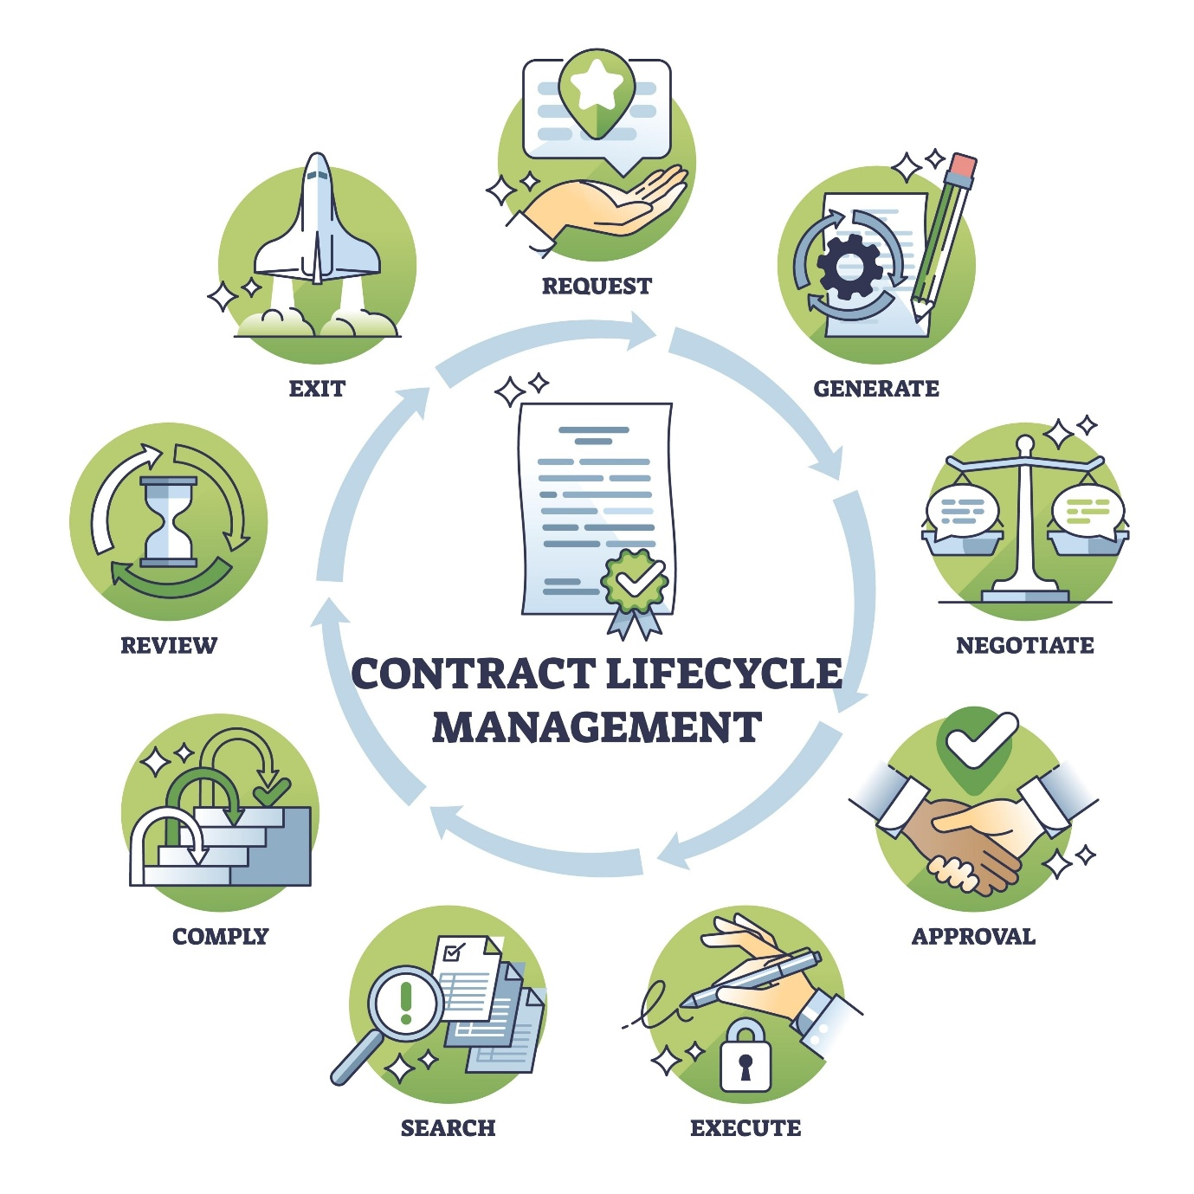
Shutterstock
- Contract Initiation (Procurement/Feasibility): This phase, which aligns with Project Initiation, begins when the need for external services is identified. It includes creating the tender documents (like the RFI/RFQ/RFP mentioned earlier) and evaluating bids. The goal is to select a contractor and formalize the agreement.
- Contract Negotiation and Award: The chosen contractor and the client negotiate the final terms and conditions, ensuring mutual understanding of the scope, cost, and schedule. The resulting document—the contract—legally defines the deliverables, quality criteria, acceptance procedures, and payment schedule.
- Contract Execution (Development and Monitoring): This phase runs parallel to Project Execution. The key activity is monitoring the contractor's performance against the contract's terms. This involves:
  - Tracking Milestones and Deliverables: Ensuring they meet the agreed-upon standards and timelines.
  - Managing Changes: Handling any scope or requirement changes using a formal Change Control Process, ensuring all amendments are legally documented.
  - Invoicing and Payment: Authorizing payments upon the successful completion and acceptance of contractually defined stages.
- Contract Closure (Acceptance and Review): This stage aligns with Project Closure. It occurs when all services and products specified in the contract have been delivered, accepted, and paid for. This includes final acceptance testing, ensuring all warranties and maintenance agreements are in place, and conducting a formal review to document the contractor's performance and lessons learned for future engagements.
Conclusion: The contract management workflow is a continuous process integrated into the project life cycle, ensuring that the legal and financial relationship between the client and contractor is monitored and fulfilled from tender to final acceptance.
Q 12. Discuss the different steps involved in the development phase of ISO 12207.
Ans: The ISO/IEC 12207 Development Process defines a structured set of steps that transform user needs into a qualified, operational software system. It aligns with the Project Execution phase and ensures rigor and traceability throughout the creation of the software product.
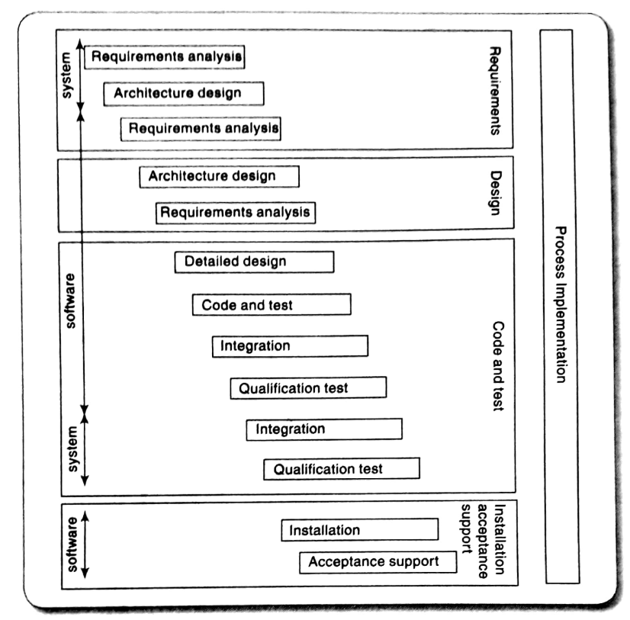
- Requirements Analysis: This initial step involves defining, analyzing, and structuring all system and software requirements, including functional, performance, and interface needs. The output is a clear, consistent set of requirements that will be used for all subsequent development activities.
- Architecture Design: A high-level structure of the software system is created, defining the major components (subsystems/modules), their responsibilities, and the interfaces between them. This step ensures the design is robust and traceable back to the overall requirements.
- Detailed Design: Each architectural component is refined into detailed design specifications. This includes defining the internal logic, data structures, and algorithms for individual software units, providing the complete blueprint for implementation.
- Code and Test (Implementation): This phase involves writing the source code based on the detailed design. Concurrently, unit testing is performed on each component to verify that it functions correctly and meets its specific design specification.
- Integration: The individually tested software units are systematically combined into larger assemblies and then into the complete software system. Integration testing is performed to ensure the interfaces and interactions between these combined components work as expected.
- Qualification Testing: This rigorous step verifies that the integrated software system satisfies all the original specified requirements. It typically includes various tests like system testing, performance testing, and security testing to confirm the quality objectives are met.
- Installation and Acceptance Support: The final software product is installed in the target environment for the client. The development team provides support during the client's acceptance testing, leading to the client's formal acceptance and sign-off (aligning with Project Closure).
Conclusion: The ISO 12207 Development Process ensures that the software is systematically built and verified through defined phases, moving from conceptual requirements to a fully qualified, deployable product.
Q 13. Use a practical example to explain how risks are analyzed and prioritized in project management.
Ans: Risk analysis and prioritization are essential steps in project management (part of the Risk Management Plan within Project Planning) used to systematically evaluate and rank risks based on their potential impact on project objectives. This allows the project team to focus resources on the most critical threats.
Example: E-Commerce Platform Development
Scenario: Building a new e-commerce website for a client.
1. Risk Analysis (Qualitative and Quantitative)
Risk analysis involves assessing two main dimensions for each identified risk: Probability (likelihood of occurrence) and Impact (severity of consequence).

Identified Risk | Probability (P) | Impact (I) | RPN (P x I)
A. Key Developer Quits | High (5) | Critical (5) | 25
B. Third-Party Payment Gateway Delay | Medium (3) | High (4) | 12
C. Minor Bug in Analytics Module | High (4) | Low (2) | 8
- Qualitative Analysis: This uses descriptive scales (e.g., Low, Medium, High) to assess P and I. For example, risk A (Key Developer Quits) has a High probability if the team has low morale, and a Critical impact because that person holds unique knowledge.
- Quantitative Analysis: This assigns numerical values (e.g., 1-5 scale) to P and I. The Risk Priority Number (RPN) is calculated by multiplying these values (P x I).
2. Risk Prioritization
Risks are prioritized based on their RPN score, with the highest score indicating the most severe threat. This method allows the team to focus limited resources on the most important risks first.
- High Priority (RPN > 15): Risk A (RPN=25) is the highest priority. It is an extreme threat requiring immediate action. The project manager must focus on mitigation strategies, such as cross-training and creating robust documentation.
- Medium Priority (RPN 8-15): Risk B (RPN=12) is a medium-level threat. The team needs to track the vendor closely and prepare a contingency plan, such as identifying a secondary payment provider.
- Low Priority (RPN < 8): Risk C (RPN=8) is a lower priority. It is addressed using standard development practices like code inspection and automated testing, rather than dedicated, high-cost mitigation strategies.
Conclusion: Risk analysis systematically measures the potential damage of a threat, and prioritization (using tools like RPN) provides a clear, objective order for addressing these threats, thereby reducing overall project vulnerability and improving the chances of a successful Project Execution.
Q 14. Elucidate the concepts in activity planning in software project management.
Ans: Activity planning is a core component of the Project Planning process, which the text explicitly states is essential to a successful project. It focuses on defining the necessary work, sequencing it, and setting the schedule to ensure the project objectives are met.
- Activity Definition (Work Breakdown Structure - WBS): This process is about defining all the project work into smaller, manageable pieces. The fundamental tool is the Work Breakdown Structure (WBS), which decomposes the total scope into discrete, task-level work elements.
- Activity Sequencing (Dependency Determination): Once activities are defined, this step identifies the logical order in which they must be performed. It determines the dependencies between activities (e.g., Task B cannot start until Task A is complete) to ensure a smooth workflow.
- Effort Estimation: For each activity, the project manager must estimate the effort required (usually in person-hours or person-days). This is crucial for determining how long the task will take and how many people are needed.
- Resource Allocation: This concept addresses who will do it and what outputs (deliverables) will be produced. It involves assigning specific resources (people with required skills, equipment, software) to each activity.
- Schedule Development (Activity Duration): This step converts the effort estimates into a realistic schedule, answering the question of when the work will be completed. It combines the activity sequences, duration estimates, and assigned resources to create the project timeline (often represented by a Gantt chart or network diagram).
- Deliverables Definition: The Project Plan is a document that describes... what outputs (deliverables) will be produced. Activity planning must clearly specify the tangible results or artifacts (deliverables) that will be created upon completion of each task.
- W5H Alignment: Effective planning must address the W5H principle (What will be done, Who will do it, When the work will be completed, Why it is being done, Where it will be done, and How it will be done) to create the best map for the journey to a completed system.
Conclusion: Activity planning transforms the project scope into a practical, time-bound roadmap by defining, sequencing, estimating, and scheduling all the necessary work components.
Q 15. Describe the limitations of traditional software project management and how modern methods overcome them.
Ans: Traditional software project management, often based on the waterfall model or heavily process-driven approaches, exhibited several limitations, particularly in handling the inherent change and complexity of software projects. Modern methods, especially Agile approaches (like those mentioned in the PDF: Scrum, XP, FDD), were developed to overcome these rigidities.
Limitations of Traditional Methods
- Inflexible to Change: Traditional methods assume that requirements can be fully defined and frozen upfront. The document notes that a primary driver for agility is the pervasiveness of change. Traditional project life cycles (like the one described in the text) struggle because changes, once introduced, are difficult and costly to implement late in the Project Execution phase.
- Delayed Customer Feedback: The traditional approach delivers working software only at the very end of the project life cycle (Project Closure). This leads to delayed feedback, meaning errors or misunderstandings in requirements are only found when the cost to fix them is highest.
- High Emphasis on Documentation: Traditional project managers often prioritize extensive, detailed documentation (e.g., plans, specifications). Modern methods address this by valuing "working software over comprehensive documentation" and emphasizing "close, yet informal (verbal) collaboration" as the most efficient communication method (as seen in XP).
- Poor Management of Chaos/Uncertainty: Traditional methods are predicated on the idea that planning can eliminate uncertainty. The document states that Scrum, a modern method, assumes "up-front the existence of chaos," highlighting that traditional approaches fail when facing the unpredictable nature of complex software projects.
How Modern Methods Overcome Limitations
- Embracing Change: Modern methods embrace change through iterative and incremental delivery. For instance, Agile approaches welcome changing requirements, even late in development, harnessing change for the customer’s competitive advantage rather than resisting it.
- Rapid, Continuous Delivery and Feedback: Modern methods prioritize the early and continuous delivery of valuable software (Agile Principle 1). Scrum, for example, delivers operational software increments every 30 days or less (Demos), providing the customer with periodic visibility and allowing for course correction.
- Focus on People and Self-Organization: Traditional management is hierarchical. Agile emphasizes that "software is developed by individuals working in teams" and that the skills and ability to collaborate are core to success. This leads to self-organizing teams (as seen in ASD), which are empowered to define the best way to get the job done.
- Risk Mitigation through Time-Boxing: By dividing the project into short, fixed-length cycles (Sprints in Scrum), modern methods mitigate risk. If an approach fails, only a small amount of effort is lost before the team can adapt and correct, making the entire development process more resilient.
Conclusion: Modern methods counter the limitations of rigid, plan-driven processes by prioritizing flexibility, rapid delivery, continuous stakeholder involvement, and a high reliance on motivated, collaborating individuals.

